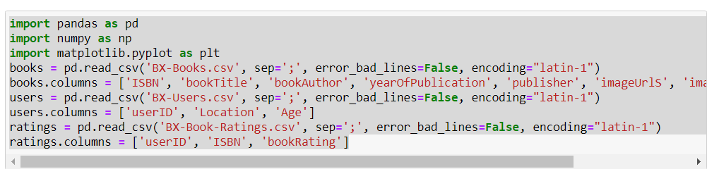

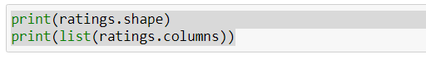

(1149780, 3)

['userID', 'ISBN', 'bookRating']

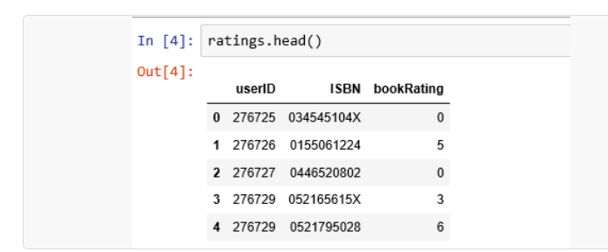

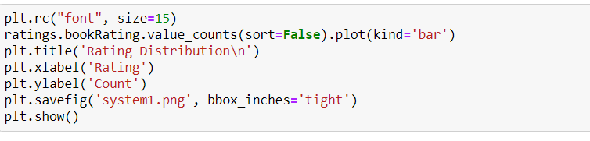

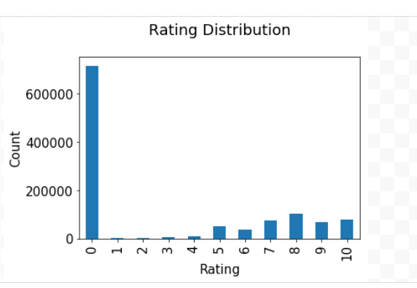

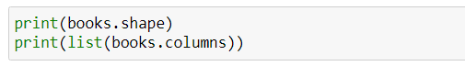

(271360, 8)

['ISBN', 'bookTitle', 'bookAuthor', 'yearOfPublication', 'publisher', 'imageUrlS', 'imageUrlM', 'imageUrlL']